horizontal line

EE208:CONTROL ENGINEERING LAB 03

# Controller design on MATLAB platform by Analog Frequency Response

## 

## Course Instructor : Dr. Sanjay Roy

## Date : 25th January 2022



## Group Number - 14

## 

## Raj Kumar Deb 2020eeb1025

## Tushar Sharma 2020eeb1325

## Tiya Jain 2020eeb1213

# TABLE OF CONTENTS

**1. OBJECTIVE** **3**

**2. GIVEN** **3**

2.1 Given Block Diagram 3

2.2 Given Information of OLTF 3

**3. THEORY** **4**

3.1 Closed Loop Transfer Function Block Diagram 4

3.2 Closed Loop Transfer Function 4

**4. OBSERVATIONS & THEIR ANALYSIS** **5**

4.1 Frequency response analysis of the system without the ventilator 5

4.2 Designing the Ventilator Transfer Function 6

Approach A) Taking Ventilator Transfer Function with only Poles 7

Approach B) Modifying the Ventilator Transfer function with poles as well as zeroes 9

Approach C) Modifying the Ventilator Transfer function with zeros only 11

4.3 Parameters Of The Final Transfer Function Over Variable Range 16

**5. CONCLUSION** **19**

**6. MATLAB SCRIPTS** **20**

# 

# 

# 

# 1. OBJECTIVE

The project requires design of a cascade ventilator transfer function for a given analog respiratory system transfer function, according to desired specifications provided.

# 2. GIVEN

### 2.1 Given Block Diagram

###### 

***Figure 2.1 Block diagram for the CLTF of the given system***

### 2.2 Given Information of OLTF

Chemoreceptor Feedback Gain (Kf) = 0.1

Circulatory System Transfer Function = $\frac{0.1}{(s+0.5)(s+0.1)(s+0.2)}$

Lungs Transfer Function = $\frac{1}{s*(time constant)+1}$

Ventilator specifications :

* Acceptable range of nominal chemoreceptor *feedback gain* is *10 times* in the worst case
* Change in *time constant* of lung transfer function is increased by up to a factor of ten in the worst case
* CLTF System should maintain a *phase margin* of ***45°***at all times

# 3. THEORY

### 3.1 Closed Loop Transfer Function Block Diagram

### 

***Figure 3.1.1 Block diagram for the CLTF with the ventilator***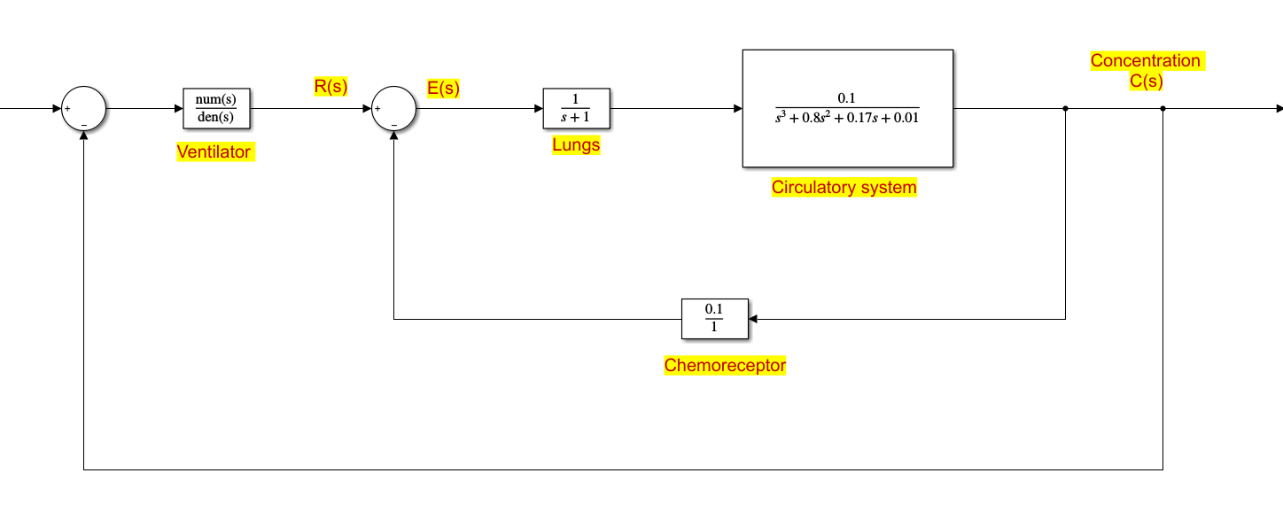

### 3.2 Closed Loop Transfer Function

The CLTF is written using the formula :

| $G_{CL}= \frac{Ventilator*(Chemoreceptors*Lungs*Circulatory System) }{1+ (1+Ventilator)*(Chemoreceptors*Lungs*Circulatory System)}$ $G_{CL}$ = $\frac{(0.1)*Ventilator}{s^{4}+1.8*s^3 + 0.97*s^2 + 0.18s + 0.02 + 0.1*(Ventilator)}$ |
| --- |

# 4. OBSERVATIONS & THEIR ANALYSIS

### 4.1 Frequency response analysis of the system without the ventilator

The prime objective of the problem is to design a “Ventilator Transfer Function” before which first we plot and investigate the frequency response of the system without the ventilator **(in order to obtain the gain and phase margin)** . We take in consideration the typical value of chemoreceptor gain i.e. Kf=0.1

**BODE PLOT ANALYSIS**

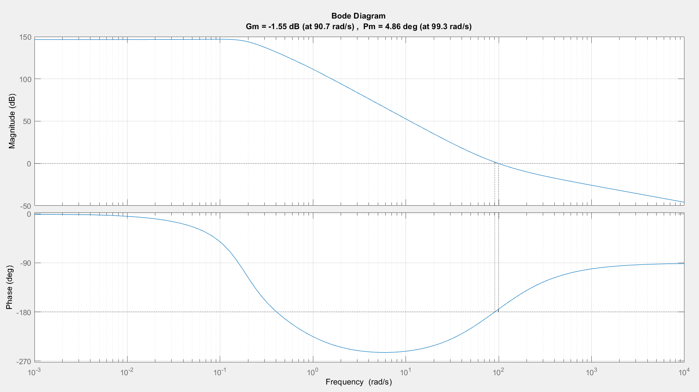

* **Gain & Phase Margin Analysis:** GM is *-13.9 dB* at *1.26 rad/sec* and PM is *21.1°* at *2.62 rad/sec* which represents the distance from the points of instability.
* **Stability Analysis :** We notice that the overall system is stable, since the gain crossover frequency (*2.62 rad/s*) and the phase crossover frequency (*1.26 rad/s*) are not the same, which is obviously expected from a healthy human being. The phase margin is *21.1°*, meanwhile the desired phase margin was *45°*.

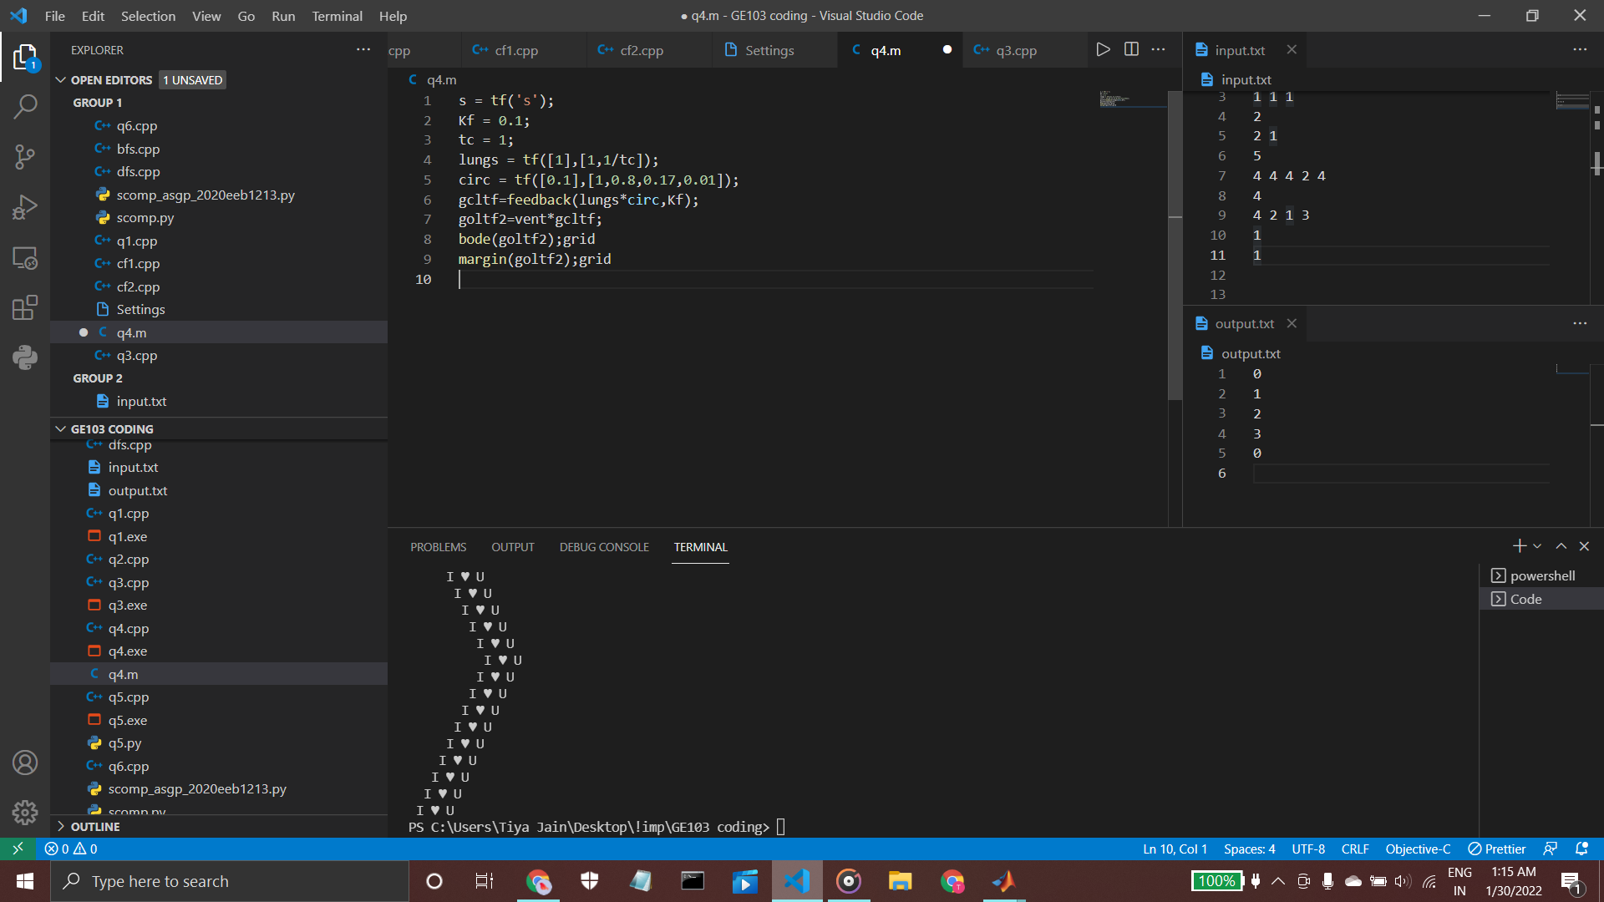

*Figure : The MATLAB snippet for Gain and Phase Margins*

### 4.2 Designing the Ventilator Transfer Function

To construct the ventilator transfer function our process of action was

* We varied the value of Time Constant from 1 to 10 with equal division of 100 to observe the trends.
* We also varied the value of Chemoreceptor Gain from 0.1 to 1 in order to make the ventilator useful for both kinds of patients.

Now according to the MATLAB code we take several forms of transfer function and try to satisfy our additional requirements of **PM (i.e. *>45° always*) , Stability and Parameter Variation.** 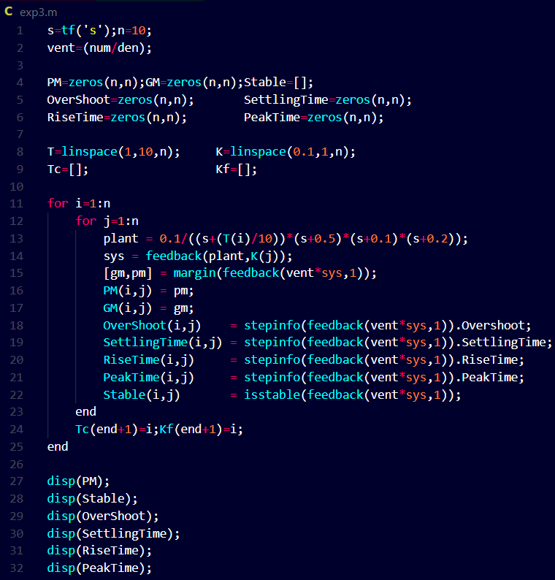

*Figure : MATLAB code to be used for finding the ventilator transfer function*

#### **Approach A) Taking Ventilator Transfer Function with only Poles**

Our first choice was of ***V = 1/(s+1)*,** which on analysis was found to be highly unstable for most of the cases, which we iterated in MATLAB using the *“for”* loop.

* By varying the numerator of these transfer functions to over a value of 1000 and also diminishing it up to around 0.003, we found *many points of instability*.
* Further on varying the pole location from s = -1 to other random locations **(just to observe the trend of the changes visible in the transfer function)** like s= -34, s =-48, s= -128 and s = -562, there were still many points of instability.
* Even Phase Margins were observed to either be *negative value* or *infinity* which was not at all desired.

| **PHASE MARGIN** |  | We can observe that the value of phase margins are not only non-positive but also sometimes infinite which is not acceptable. |
| --- | --- | --- |
| **STABILITY ANALYSIS** |  | One of the measures for stability is the location of poles. This system contains poles with their *real part as positive*, which is an indicator of instability. |

**Figure : Frequency Analysis for Tf = 1/(s+1)**

Hence due to the above reasons , we chose to add another pole to our transfer function.

Our second choice was of  ***V = 1/[(s+1)*(s+2)]*** . But, for this ventilator function also, there were a high number of unstable cases even on varying the location of poles (to the extent of s=-64,-90) and numerator coefficients(again between 1000 and 0.003).

| **PHASE MARGIN** |  | We can observe that the value of phase margins are not only non-uniform and negative but also go to infinity at many points which is not acceptable. |
| --- | --- | --- |
| **STABILITY ANALYSIS** |  | This system contains poles with their *real part as positive*, which is an indicator of instability. We can notice that the different root locus arising due to variations are *coming closer* to each other. |

**Figure : Frequency Analysis for Tf = 1/[(s+1)*(s+2)]**

From above observations we deduce that adding poles to the system wasn’t of much help and we conclude the following trends:

* The addition of the left half pole led to slow down of system response whereas the addition of the right half pole led to less stability as seen from their *step responses*.
* As the pole moves away from the imaginary axis the effect was observed to be more pronounced.

#### **Approach B) Modifying the Ventilator Transfer function with poles as well as zeroes**

So, further modification was made by adding a zero to it, with our new transfer function as ***V = (s+3)/[(s+1)*(s+2)]*.** Even in this case, variation of poles and numerator coefficients to the same extent as before along with varying our zero from s=-3 to s=-88, the results were not satisfactory, the instability persists.

| **PHASE MARGIN** |  | The value of phase margins are not only non-uniform but also sometimes negative & infinity which is not acceptable just like the previous case. |
| --- | --- | --- |
| **STABILITY ANALYSIS** |  | One of the measures for stability is the location of poles. This system contains poles with their *real part as positive*, which is an indicator of instability. Also we can see by addition of zeros, the *poles move towards stability*. |

**Figure : Frequency Analysis for Tf = (s+3)/[(s+1)*(s+2)]**

Inorder to reduce the instability trend we decided to check for an additional pole ***V = (s+3)/[(s+1)*(s+2)*(s+4)]*** . For this case, we received an unstable system with negative and even infinite Phase Margins for a few cases. Even on varying the poles up to s=-68,-78,-86, zero upto s=-96 and numerator coefficients from 1000 to 0.003, the system remained unstable. But the number of cases for which we receive a suitable value of phase margins have never been better than previous cases so far. This may indicate that the addition of zeros in our transfer function is favorable.

| **PHASE MARGIN** |  | Just like the previous case some values are negative and infinity, but here the range of negative values is better. |
| --- | --- | --- |
| **STABILITY ANALYSIS** |  | This system contains poles with their *real part as positive*, which is an indicator of instability. Also we can see by addition of zeros, the *poles move towards stability*. |

**Figure : Frequency Analysis for Tf = (s+3)/[(s+1)*(s+2)*(s+4)]**

So after trying a few more combinations of poles and zeros, we shifted our focus on only zeroes for this transfer function.

Involvement of poles to our ventilation system will ***increase the response time*** of the system. Reducing the number of poles by inclusion of zeros will make the system respond instantaneously. So, *instead of adding poles we add zeros* only. This will also enhance the stability.

#### **Approach C) Modifying the Ventilator Transfer function with zeros only**

Before we started adding zeros in our system , we had to decide whether to add zero to the left half or right half of the plane.

We found that the right half plane zero has gain similar to that of the left half plane but its phase nature is like a pole i.e. it adds negative phase to the system. This addition of negative phase would reduce our phase margin and also cause delay to the system response, which will eventually turn into instability if not taken care of. So we use LHP zero which contributes a 90° phase increase in the system which leads to stability.

We started by choosing a simple transfer function with one zero, ***V = s+1.*** The system is unstable for most of the cases, further varying the numerator coefficient from 0.003 to 1000, along with the location of the zero upto s = -132, does not yield favorable phase margins. The system still remains unstable.

| **PHASE MARGIN** |  | We observe that there are *fewer ‘infinity’ values* as we add zeros to the ventilator. |
| --- | --- | --- |
| **STABILITY ANALYSIS** |  | This system contains poles with their *real part as positive*, which is an indicator of instability. Also we can see by addition of zeros, the *poles move towards stability*. |

**Figure : Frequency Analysis for Tf = (s+1)**

Then we decided to include one more zero, and hence came up with a new transfer function  ***V = (s+1)*(s+2).*** This transfer function led us to an overall unstable system but the number of ‘infinity’ values reduced. But varying the zeroes of V from s=-1,-2 to s=-128,-142, and also the numerator coefficient from 1000 to 0.003, the system still remains unstable.

| **PHASE MARGIN** |  | We can observe that the value of phase margins are not only non-uniform but also sometimes negative & infinity which is not acceptable. We observe that there are *fewer ‘infinity’ values* as we add zeros to the ventilator. |
| --- | --- | --- |
| **STABILITY ANALYSIS** |  | One of the measures for stability is the location of poles. This system contains poles with their *real part as positive*, which is an indicator of instability. Also we can see by addition of zeros, the *poles move towards stability*. |

**Figure : Frequency Analysis for Tf = (s+1)*(s+2)**

We further included one more zero, and came up with the transfer function ***V=(s+1)*(s+2)*(s+3).*** This directed us to an unstable system initially, but on increasing the value of numerator coefficient it moved towards stability. We observed instability for numerator coefficient up to 12 and stability was achieved when it was changed to 12.1 Even on obtaining stability for all our test cases, we obtained the minimum phase margin of 37.48° and hence further increased the coefficient value so that it reaches at least 45°. At the value of ***13.88***. The phase margin ranged from 45.07° to 65.35°. Then in order to reduce the maximum value of phase margin while maintaining all values at least up to 45°, we started manipulating the location of zeros.

| **PHASE MARGIN** |  | We can observe that the value of phase margins are uniform and *near 45°* as desired . |
| --- | --- | --- |
| **STABILITY ANALYSIS** |  | There are no positive poles in this system. Adding zeros removed the unstable poles. |

**Figure : Frequency Analysis for Tf =12.1* (s+1)*(s+2)*(s+3)**

On increasing the distance between two zeros to quadruple of earlier case we obtained **V = (s+1)*(s+5)*(s+9).** Again on analyzing and adjusting the numerator coefficient for this case (the value comes out to be 37.8), we obtain that for***V = 37.8*(s+1)*(s+5)*(s+9)***, the phase margin ranges from 45.08° to 52.97° which indicates that the range of phase margin reduces on increasing the distance between the zeros.

| **PHASE MARGIN** |  | The Phase Margin is now within the range of *45-55*. Further it can be improved by more variations. |
| --- | --- | --- |
| **STABILITY ANALYSIS** |  | This system contains poles with their *real part as negative*, which is an indicator of stability. The root locus including the variations are almost the same. |

**Figure : Frequency Analysis for Tf = 37.8* (s+1)*(s+5)*(s+9)**

Following the trend observed, we kept on increasing the distance between the zeros and checking the corresponding ranges of phase margins. **Increasing the Gain**, the poles of the CLTF move from the Right Half Plane to the Left Half Plane forming a *stable system*.

**Finally, on taking the zeroes quite apart at s=-1,-65,-129 and adjusting the numerator coefficient to 507.1, the range of phase margin was obtained to be from 45.004° to 45.60°, and our ventilator performed well with stability all over the desired range.**

**So, we selected finally our ventilator transfer function as**

**V = (507.1)*(s+1)*(s+65)*(s+129)**

### 4.3 Parameters Of The Final Transfer Function Over All Variable Range

**\*\*Graph plotted has variation of 100x100 points of Tc & Kf**

**Scale Tc (1 to 0.1) : (1,100) Kf (0.1 to 1) : (1,100)**

| **J = (1 to 0.1)** *(Rows)* | **Kf = (0.1 to 10)** *(Columns)* |
| --- | --- |
| **PHASE MARGIN** |  |
| **STEP RESPONSE** |  |
| **OVERSHOOT** |  |
| **SETTLING TIME** |  |
| **RISE TIME** |  |
| **PEAK TIME** |  |

* We observe that there is practically no effect of variation of Kf in system parameters. Time constant maintains an inverse relationship with Phase Margin whereas direct relationship with Peak Time, Rise Time, Settling Time, Overshoot.
* Step responses for given variations seem to be handled perfectly without much change in system parameters. This is also evident from the below mentioned frequency response analysis.

| **BODE PLOT ANALYSIS** | **STABILITY ANALYSIS** |
| --- | --- |
|  |  |
| * From the following bode plot it is evident that the phase margin for all the range of frequencies will be +ve. * Moreover the phase margin after obtaining from each graph came out to be in the range of 45°-45.6° | * The root locus graph of all the transfer functions considering the variation of Time Constant and Kf is plotted above. We observed that the plot has minimal differences between each variation. * The poles are on the left half of the plane signifying the stability of the overall CLTF. |

# 

# 5. CONCLUSION

* Using the frequency response method we concluded the design of the analog system by taking in consideration many possible combinations of Poles & Zeros. We also examined the difference between addition of poles & zeros and their effect on the overall system.
* With the help of MATLAB we observed the changes on varying the gain and distance between the zeros, and selected our ventilator transfer function accordingly.
* A ***tradeoff*** can be seen between the increasing stability and the decreasing values of the Phase Margin. For that reason, to counter this we increased the Gain as well as the magnitude of the zeros.
* The ventilator transfer function that we obtained is

**VentilatorTF = *(507.1)*(s+1)*(s+65)*(s+129)***

$G_{Overall CLTF}$ = $\frac{50.71s^{3}+9888s^{2}+4.35e05s + 4.252e05}{s^{4} + 52.51s^{3} + 9889s^{2} + 4.35e05s + 4.252e05}$

# 6. MATLAB SCRIPTS

